CREATING MICROSERVICES FOR ACCOUNT AND LOAN

Name: Shubham Sangram Bej

Objective
The objective of this hands-on is to understand the fundamentals of Microservices Architecture by developing two independent Spring Boot RESTful web services. Each microservice is implemented as a separate Maven project with its own configuration, dependencies, and execution environment. The Account and Loan services expose REST APIs that return dummy data, eliminating the need for backend database connectivity.

Software Requirements
- IntelliJ IDEA 2026.1.4
- Java Development Kit (JDK 21)
- Spring Boot 4.1.0
- Maven
- Git
- GitHub
- Web Browser (Chrome/Edge)

Project Overview
Two independent microservices were developed as part of this hands-on:
- Account Microservice
- Loan Microservice
Each service was created as an individual Spring Boot application with a separate Maven configuration (pom.xml) and independent execution. Both services were configured to run simultaneously using different server ports.

Account Microservice

Objective
To create a RESTful web service that returns account information based on the account number.

Implementation
- Created a Spring Boot Maven project named account.
- Added the required dependencies:
  - Spring Web
  - Spring Boot DevTools
- Implemented a model class (Account) to represent account details.
- Created a REST controller exposing the required endpoint.
- Configured the application to run on port 8080.
- Verified the REST API using a web browser.

REST Endpoint
GET /accounts/{number}

Sample Request
http://localhost:8080/accounts/180405

Sample Response
{
"number": "180405",
"type": "Savings",
"balance": 696914.0
}
Screenshot:
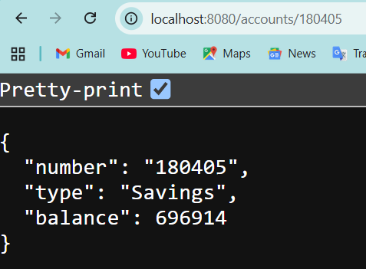

Codes used
Account.java:
package com.cognizant.account.model;
public class Account {
private String number;
private String type;
private double balance;
public Account() {
}
public Account(String number, String type, double balance) {
this.number = number;
this.type = type;
this.balance = balance;
}
public String getNumber() {
return number;
}
public void setNumber(String number) {
this.number = number;
}
public String getType() {
return type;
}
public void setType(String type) {
this.type = type;
}
public double getBalance() {
return balance;
}
public void setBalance(double balance) {
this.balance = balance;
}
}

AccountController.java:
package com.cognizant.account.controller;
import com.cognizant.account.model.Account;
import org.springframework.web.bind.annotation.*;
@RestController
@RequestMapping("/accounts")
public class AccountController {
@GetMapping("/{number}")
public Account getAccount(@PathVariable String number) {
return new Account(
number,
"Savings",
696914
);
}
}

Loan Microservice

Objective
To create a RESTful web service that returns loan information based on the loan account number.

Implementation
- Created a Spring Boot Maven project named loan.
- Added the required dependencies:
  - Spring Web
  - Spring Boot DevTools
- Implemented a model class (Loan) to represent loan details.
- Created a REST controller exposing the required endpoint.
- Configured the application to run on port 8081 to avoid port conflicts.
- Verified the REST API using a web browser.

REST Endpoint
GET /loans/{number}

Sample Request
http://localhost:8081/loans/SHUBH108

Sample Response
{
"number": "SHUBH108",
"type": "Car",
"loan": 700000.0,
"emi": 3060.0,
"tenure": 24
}

Screenshot:
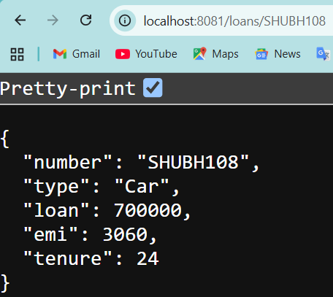

Codes used

Loan.java:
package com.cognizant.loan.model;
public class Loan {
private String number;
private String type;
private double loan;
private double emi;
private int tenure;
public Loan() {
}
public Loan(String number, String type, double loan, double emi, int tenure) {
this.number = number;
this.type = type;
this.loan = loan;
this.emi = emi;
this.tenure = tenure;
}
public String getNumber() {
return number;
}
public void setNumber(String number) {
this.number = number;
}
public String getType() {
return type;
}
public void setType(String type) {
this.type = type;
}
public double getLoan() {
return loan;
}
public void setLoan(double loan) {
this.loan = loan;
}
public double getEmi() {
return emi;
}
public void setEmi(double emi) {
this.emi = emi;
}
public int getTenure() {
return tenure;
}
public void setTenure(int tenure) {
this.tenure = tenure;
}
}

LoanController.java:
package com.cognizant.loan.controller;
import com.cognizant.loan.model.Loan;
import org.springframework.web.bind.annotation.*;
@RestController
@RequestMapping("/loans")
public class LoanController {
@GetMapping("/{number}")
public Loan getLoan(@PathVariable String number) {
return new Loan(
number,
"Car",
700000,
3060,
24
);
}
}

Port Configuration
Since both microservices are independent applications, they cannot run on the same port simultaneously.
Microservice | Server Port
Account Service | 8080
Loan Service | 8081
The Loan microservice was configured to use port 8081, allowing both services to run concurrently without port conflicts.

Testing
The following REST endpoints were tested successfully:
Endpoint | Result
/accounts/180405 | Successfully returned account details
/loans/SHUBH108 | Successfully returned loan details
All REST APIs returned the expected JSON response.

Conclusion
The objectives of the "Creating Microservices for Account and Loan" hands-on were successfully achieved. Two independent Spring Boot microservices were developed and executed successfully. Both services exposed REST endpoints that returned the expected JSON responses. The applications were configured to run on separate ports, demonstrating the basic principles of microservices architecture and independent service deployment.

